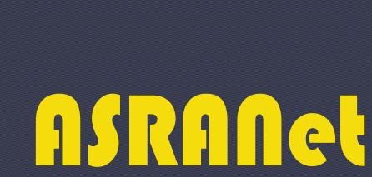

4th International Conference on Smart & Green Technology for Shipping and Offshore Decommissioning (SMATECH 2023), 24-25 April 2023, ONLINE

Consent to publish & of Copyright for Contributors to Conference Proceedings

It is necessary for the author(s) to transfer the copyright in a formal written manner to protect the papers contributed to the conference against unauthorised use and to authorise dissemination of the papers by means of off-prints, legitimate photocopies, microform editions, reprints, translation, document delivery, and secondary information sources such as abstracting and indexing services including data bases.

The consent ensures that ASRANet Ltd has the author’s permission to publish the paper. Title of Paper: Ship navigation using Reinforcement Learning based controllers

Author(s):Sivaraman Sivaraj, Suresh Rajendran

Name of Conference**:**

4th International Conference on Smart & Green Technology for Shipping and Offshore Decommissioning (SMATECH 2023), 24-25 April 2023, ONLINE

1. The Author(s) hereby assigns to ASRANet Ltd (hereinafter referred to as The Publisher) the copyright to the paper named above whereby the Publisher shall have the exclusive right to publish the said paper in print and in electronic form and translations of it wholly or in part throughout the world during the full term of copyright including renewals and extensions and all subsidiary rights.
2. The Author(s) retains the right to republish the paper in any printed collection consisting solely of the Author’s own works without charge and subject only to notifying the Publisher of the intent to do so and ensuring that the publication by the Publisher is duly credited and that the relevant copyright notice is repeated verbatim.
3. The Author(s) guarantees that the paper is original, except for such excerpts from copyrighted works as may be included with permission of the copyright holder(s) and author(s) thereof, that it contains no libellous statements and does not infringe on any copyright, trademark, patent, statutory right or proprietary right of others.
4. The Author(s) guarantees that the paper has not been published previously and is not under consideration for publication elsewhere and signs for and accepts responsibility for releasing this material along with all co-authors signatures and that any necessary permission to quote from another source has been obtained. (A copy of any such permission to be attached with this form.)

Name: Suresh Rajendran Signature:

Name: Sivaraman Sivaraj Signature:

Date: